## System Decomposition

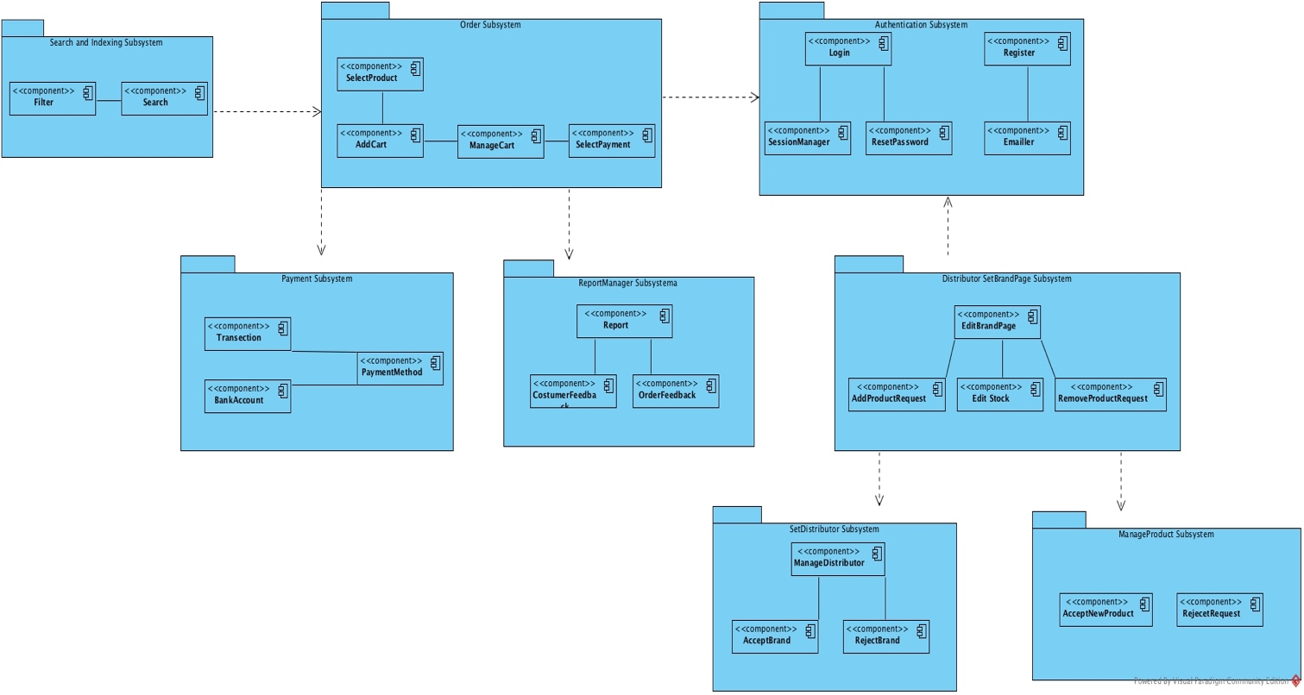

* *Order Subsystem:* This subsystem is responsible for ordering and creating new order-requesting units. This subsystem is also the subscriber to the payment subsystem, making order based on products when any payment is made.
* *Authentication Subsystem:* This subsystem is fully responsible for user login and register. Authorized persons can access the system through this subsystem. Customers and vendors can register with the system through this system.
* *Payment Subsystem:* This subsystem is responsible for managing payment transactions and credit card, bank account balance management. This subsystem is in communication with the order subsystem.
* *ReportManager Subsystem:* This sub-system is responsible for creating problems and handling them. In addition, the feedback generated by this Subsystem User is responsible for managing the complaints. It provides related problems and functions.
* *SearchAndIndexing Subsystem:* This subsystem is responsible for the detailed product search and listing of the user. The user can search for the product as he / she wants. This subsystem is associated with ordering.
* *SetBrandPage Subsystem:* This subsystem is related to managing vendor's own systems. The seller wants to sell the products he wants to sell through this system. The condition is that there is no manager approval and registration in order to do this.
* *ManagerProduct Subsystem:* This subsystem is a system that allows the admin to add and remove products. Admin can add and remove products through this system. it is associated with the subsystem belonging to the distributor.
* *SetDistributor Subsystem*: This subsystem is a system that allows vendor approval. the manager can add or remove the vendors it approves. it is associated with the subsystem belonging to the distributor.

## Hardware Software Mapping

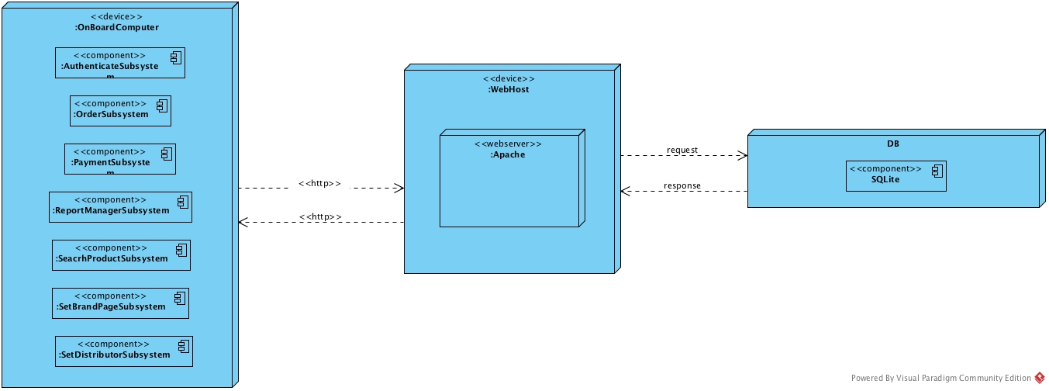

Herbco is web-based online herb shopping system. Herbco is connecting to web server when user tries to visit and login in the system. Herbco system connects to web host with http protocol. Multiple users can access web server simultaneously. Web host have web server. Web server is written with Java. The system connects to database by using Javax libraries. Users that customer, restaurant owner, Admin and Manager which just make an order, use the Herbco system. These actors communicate with Herbco system with http-https protocol web browser in their personal computers. Furthermore, Herbco database server using SQLite for communicating. SQLite is a relational database management system found in a programming library. SQLite is a popular choice as embedded database software for local / client storage applications such as web browsers. It is arguably the most widely deployed database engine, as it is used today by several widespread browsers, operating systems, and embedded systems (such as mobile phones), among others. SQLite has bindings to many programming languages. The browsers Google Chrome, Opera, Safari, and the Android Browser all allow for storage information, and a SQLite database within the browser, using the Web SQL database technology, although this is rapidly becoming deprecated